LED DOT MATRIX DISPLAY MODULE

Introduction

The LED Matrix Display is Package of LEDs to form a display module. It is a 2-dimensional patterned array, used to represent characters, symbols and images. Every type of modern technology uses dot matrices for display of information, including cell phones, televisions, and printers.

Overview

An LED matrix or LED display is a large, low-resolution form of dot-matrix display, useful both for industrial and commercial information displays as well as for hobbyist human–machine interfaces. It consists of a 2-D diode matrix with their cathodes joined in rows and their anodes joined in columns (or vice versa). By controlling the flow of electricity through each row and column pair it is possible to control each LED individually. By multiplexing, scanning across rows, quickly flashing the LEDs on and off, it is possible to create characters or pictures to display information to the user. By varying the pulse rate per LED, the display can approximate levels of brightness. Multi-colored LEDs or RGB-colored LEDs permit use as a full-color image display. The refresh rate is typically fast enough to prevent the human eye from detecting the flicker.

Characteristics

In this Project, we are using an 8x8 bi color LED matrix Display, here are the Characteristics:

1. It consist of 64 LEDs in total
2. It has 8 pins for the Rows and 8 pins for both the green LEDs and red LEDs.

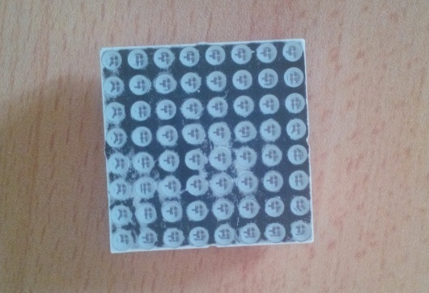

Application

1. They can be used to Display text Information
2. They can be to display Animations

Hardware

This section consists of the Hardware parts that were used and the Schematics.

Components list

1. 8x8 LED Dot matrix display.
2. 2 x 74HC595 Shift Register IC.
3. 8 × Current-Limiting Resistors (220 ohms).
4. Arduino Uno
5. Jumper wires

Circuit Diagram

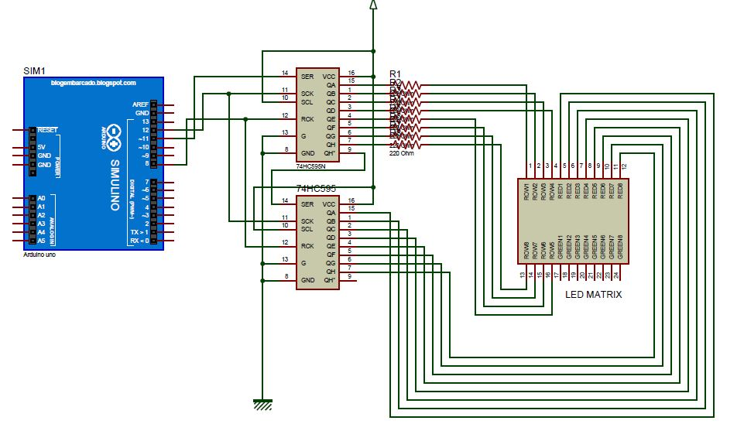

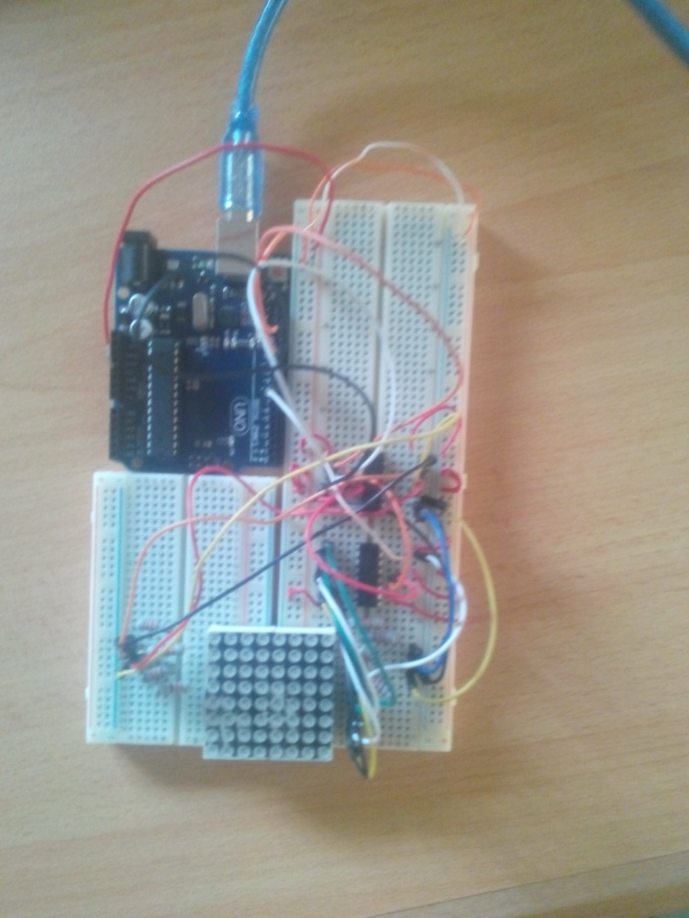

Connections

The Schematic diagram above is relevant to the specific dot matrix unit that I used in creating this project, a mini 8×8 bi-color dot matrix display unit.

Table for the Connections

|  |  |  |
| --- | --- | --- |
| Row | Shift Register 1 | LED Matrix Pin |
| Row 1 | 15 | 1 |
| Row 2 | 1 | 2 |
| Row 3 | 2 | 3 |
| Row 4 | 3 | 4 |
| Row 5 | 4 | 5 |
| Row 6 | 5 | 6 |
| Row 7 | 6 | 7 |
| Row 8 | 7 | 8 |

|  |  |  |
| --- | --- | --- |
| Column | Shift Register 2 | LED Matrix Pin |
| Column 1 | 15 | 5 |
| Column 2 | 1 | 6 |
| Column 3 | 2 | 7 |
| Column 4 | 3 | 8 |
| Column 5 | 4 | 9 |
| Column 6 | 5 | 10 |
| Column 7 | 6 | 11 |
| Column 8 | 7 | 12 |

Software

Code for the Display of the Alphabets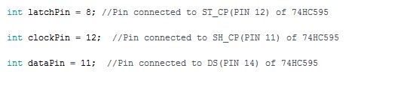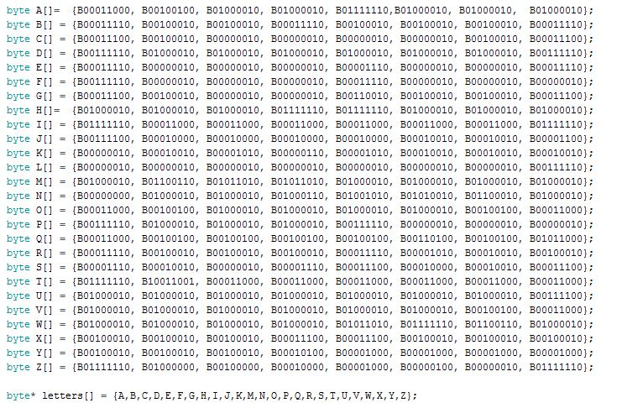

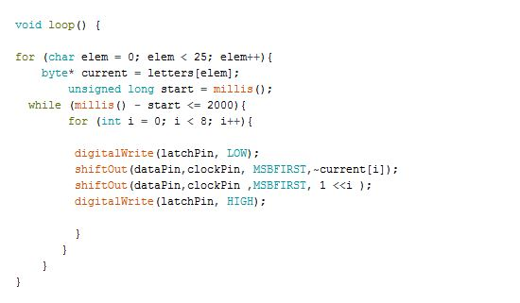

Code for the Scrolling Animation

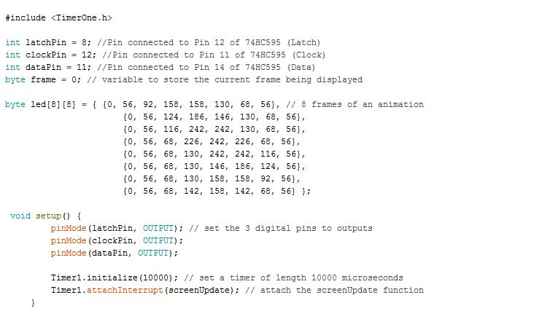

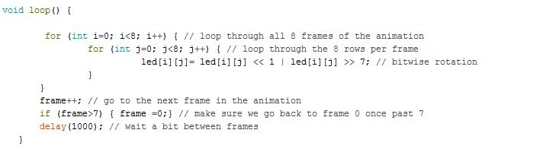

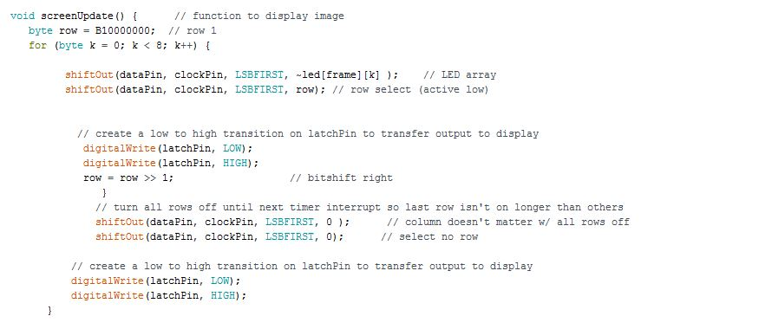

Result

The Project was a Success. We were able to display the alphabets and make a scrolling animation.

Observation

My observation is that you have to be careful of your connections so as not to make mistakes.

Challenges

For prototyping on breadboards you need a lot of jumper wire which can make the work a bit difficult and i advice you use a bigger breadboard for this kind of project and Make sure you connect things slowly and methodically.